Homework name: class: due in: 02/04/17
Write the definition of each micro:bit features in the given boxes
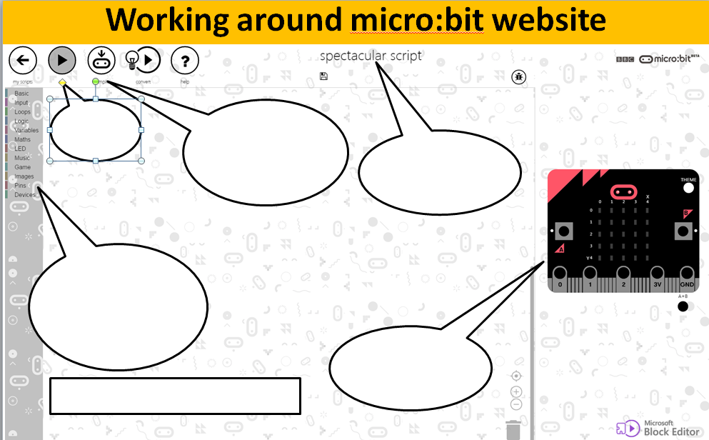

What is computational thinking?

What is algortihm in programming?

Explain why sequencing is important in programming?

